Grade 7 Accelerated · Unit 6 · Lesson 5  Distance on the Coordinate Plane  Independent Set 6.05 ANSWER KEY | Name  Date  Period

Six questions, on your own, in silence. Show the step that does the work.
1. Find the distance between 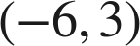 and 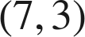.
13 units
Same y: 7 − (−6) = 13.

2. Find the distance between 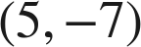 and 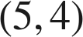.
11 units
Same x: 4 − (−7) = 11.

3. Find the distance between 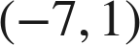 and 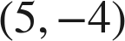.
13 units
Across 12, down 5; 144 + 25 = 169.

4. Find the distance between 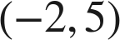 and 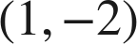, to the nearest tenth.
√58 ≈ 7.6 units
Across 3, down 7; 9 + 49 = 58.

5. How far is 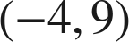 from the origin, to the nearest tenth?
√97 ≈ 9.8 units
Legs 4 and 9; 16 + 81 = 97.

6. On a map in kilometers, a pool is at 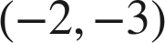 and a park at 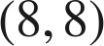. How far apart are they in a straight line, to the nearest tenth of a kilometer?
√221 ≈ 14.9 km
Across 10, up 11; 100 + 121 = 221.

